A Project Report On
E-Farmer
2022-23

TABLE OF CONTENTS

➢ CHAPTER 1 Page No
- INTRODUCTION:

  - Objective 6
  - Introduction 7
  - Technology used 8
  - Scope 9
  - Software requirement & Hardware requirement 10

- CHAPTER 2

2. LITERATURE SURVEY:

2.1 SRS 11
2.2 Feasibility Report 13
2.3 Modeling Diagram 14
2.3.1 Use case Diagram 15
2.3.2 E-R Diagram 16
2.3.3 Class Diagram 17

CHAPTER 3
3. CODING:

3.1 Platform Used 18
  - Coding 22
Front end 23
Back end 29

- CHAPTER 4

4. TESTING 32

- CHAPTER 5

5. SCREEN LAYOUT 34

- CHAPTER 6

6. CONCLUSION AND FUTURE ENHANCEMENT:

6.1 Conclusion 38
6.2 References 39

Chapter 1:

1.1Objective

Indian farmers face lot of problem when it comes to buying seeds and fertilizers from authorized channels
at the right price. Some applies to selling the farm produce at the right price so that farming becomes
profitable occupation. Need of an hour is to build a E-Portal for farmer where in they can buy seeds and
fertilizers at the optimal price. This portal should also allow consumers to bid/ask for the farm produce thus
eradicating middle man and benefiting both farmers and consumers.

1.2 Introduction

Our idea is to design an E-PORTAL/Mobile App (platform) between the farmer and the authorised channels. So the farmers can buy seeds and fertilizers at the optimal price without the intererence of any other authority(middle man). Farmer can create profile on portal with their mobile number and will receive OTP for verification, then they can create their password for future logins. Similarly other organisation/authorities can also create their profiles. after creating profiles they have to provide required details. farmers/organisation can easily buy or sell seeds, fertilizer. Many farmers have extra seeds so he can login and then upload Details of seeds(category, name, price, Image of seeds/Video) and sell seeds to other farmers/organisation . Organisation login and then upload details of seeds and fertilizers for selling. Farmers can search particular seed on portal/app then buy seed and fertilizer and they payment through online or offline(cash).If Farmer have any query then farmer can send feedback/complain. Farmer can communicate with farmers and Organization. If farmers and Organisation have no transport services then transportation services also Provided by the Admin with Extra Charges.

1.3 TECHONOLOGY USED

SQL Server- Database for storing Data and MVC For API designing(Connectivity B/W server

ASP .NET-(Bootstrap, Java Script, CSS, J-Query, Ajax) For Web Designing.

Android (JAVA) for Mobile App Designing

1.4 Scope
This document is the only one that describes the requirements of the system. It is meant for the use by the developers , and will also by the basis for validating the final delivered system. Any changes made to the requirements in the future will have to go through a formal change approval process. The developer is responsible for asking for clarifications, where necessary, and will not make any alterations without the permission of the client.

1.5 Hardware & Software Specification

Software –
- Platform - Windows (XP/7/10) /Unix/Solaris
- SQL server Management Studio.
- Visual Studio.
- Internet explorer

Hardware
- Color monitor
- Processor - 1.7GHz-3.2GHz
- RAM - 256 MB
- Hard Disk - 40 GB
- Keyboard - 101 keys
- Mouse - Any pointing device

Chapter 2-

2. LITERATURE SURVEY:

2.1 Software Requirement Specification Document
What is SRS?
Software Requirement Specification (SRS) is the starting point of the software developing activity. As system grew more complex it became evident that the goal of the entire system cannot be easily comprehended. Hence the need for the requirement phase arose. The software project is initiated by the client needs. The SRS is the means of translating the ideas of the minds of clients (the input) into a formal document (the output of the requirement phase.)
The SRS phase consists of two basic activities:
- Problem/Requirement Analysis: The process is order and more nebulous of the two, deals with understand the problem, the goal and constraints.
- Requirement Specification: Here, the focus is on specifying what has been found giving analysis such as representation, specification languages and tools, and checking the specifications are addressed during this activity.
The Requirement phase terminates with the production of the validate SRS document. Producing the SRS document is the basic goal of this phase.
ROLE OF SRS:
The purpose of the Software Requirement Specification is to reduce the communication gap between the clients and the developers. Software Requirement Specification is the medium though which the client and user needs are accurately specified. It forms the basis of software development. A good SRS should satisfy all the parties involved in the system.

PROJECT DEFINITION

The E-FARMER project has been divided into 7 modules. They are
- Registration
- Login
- Enquiry
- Admin
- Buy
- Sale
Module-One Registration: This module consists of the following sub modules:
- Registration of Farmer
- Registration of Organization
Module-Two Login : This module is divided into three sub modules. They are
- Admin Login
- Farmer Login
Module-Three Enquiry: A person can send enquiry request to admin.

Module-Four Admin : This module is divided into sub modules. They are
- Admin Home
- Admin Profile
- Check orders, transaction, tax, transport and emergency request.
Module-Five Farmer: This module is divided into sub modules. They are
- Farmer Home
- Farmer Profile
- Buy seeds
- Sale seeds

2.2Feasibility analysis
Feasibility study is an important phase in the software development process. It enables the developer to have an assessment of the product being developed. It refers to the feasibility study of the product in terms of outcomes of the product, operational use and technical support required for implementing it.Feasibility study should be performed on the basis of various criteria and parameters. The various feasibility studies are:

- Economic Feasibility
- Operational Feasibility
- Technical Feasibility

- Economic Feasibility: It refers to the benefits or outcomes we are deriving from the product as compared to the total cost we are spending for developing the product. If the benefits are more or less the same as the older system, then it is not feasible to develop the product.

- Operational Feasibility: It refers to the feasibility of the product to be operational. Some products may work very well at design and implementation but may fail in the real time environment. It includes the study of additional human resource required and their technical expertise.

- Technical Feasibility: It refers to whether the software that
is available in the market fully supports the present application. It studies the pros and cons of using a particular software for the development and its feasibility. It also studies the additional training needed to be given to the people to make the application work.
Implementation Plan:
The main plan for the system developed is to mimic the existing system as it is in the proposed system.

2.3 Design Phase-

Design is the first step in the development phase for any techniques and principles for the purpose of defining a device, a process or system in sufficient detail to permit its physical realization.
Once the software requirements have been analyzed and specified the software design involves three technical activities design, coding, generation and testing that are required to build and verify the software.
The design activities are of main importance in this phase, because in this activity, decisions ultimately affecting the success of the software implementation and its ease of maintenance are made. These decisions have the final bearing upon reliability and maintainability of the system. Design is the only way to accurately translate the customer’s requirements into finished software or a system.

1 Use case Diagram
2 Event Diagram
3 E-R Diagram
4 Data Flow Diagram
5 Class Diagram
6 Sequence Diagram

Use Case Diagram

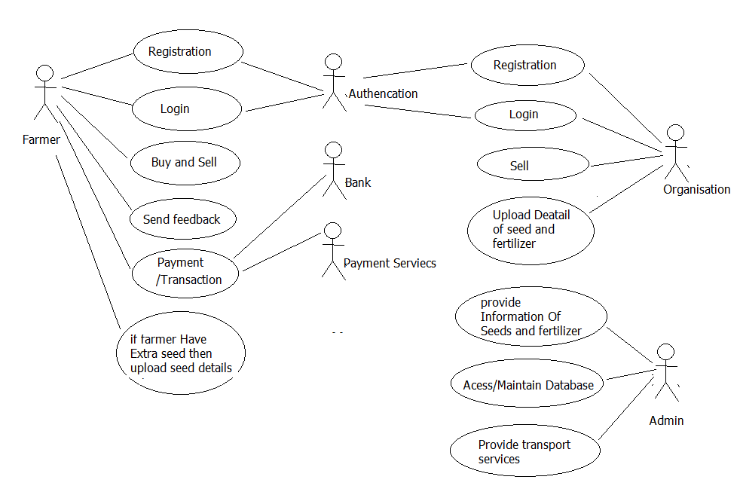

E R diagram-

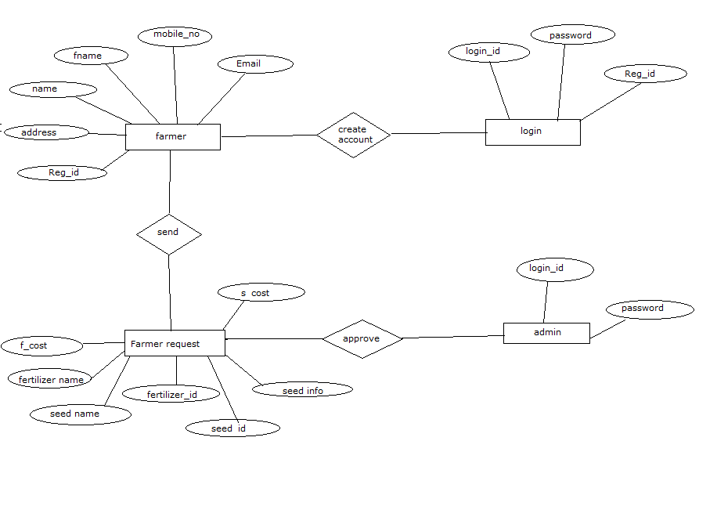

Chapter 3-Coding

3.1 Plateform used-

3.1.1Features of Asp.Net- ASP.NET is a web development platform, which provides a programming model, a comprehensive software infrastructure and various services required to build up robust web applications for PC, as well as mobile devices.
ASP.NET works on top of the HTTP protocol, and uses the HTTP commands and policies to set a browser-to-server bilateral communication and cooperation.
ASP.NET is a part of Microsoft .Net platform. ASP.NET applications are compiled codes, written using the extensible and reusable components or objects present in .Net framework. These codes can use the entire hierarchy of classes in .Net framework.
The ASP.NET application codes can be written in any of the following languages:
- C#
- Visual Basic.Net
- Jscript
- J#
ASP.NET is used to produce interactive, data-driven web applications over the internet. It consists of a large number of controls such as text boxes, buttons, and labels for assembling, configuring, and manipulating code to create HTML pages.

3.1.2 Features of C# - C# is a modern, general-purpose, object-oriented programming language developed by Microsoft and approved by European Computer Manufacturers Association (ECMA) and International Standards Organization (ISO).
C# was developed by Anders Hejlsberg and his team during the development of .Net Framework.
C# is designed for Common Language Infrastructure (CLI), which consists of the executable code and runtime environment that allows use of various high-level languages on different computer platforms and architectures.
The following reasons make C# a widely used professional language −
- It is a modern, general-purpose programming language
- It is object oriented.
- It is component oriented.
- It is easy to learn.
- It is a structured language.
- It produces efficient programs.
- It can be compiled on a variety of computer platforms.
- It is a part of .Net Framework.

Integrated Development Environment (IDE) for C#
Microsoft provides the following development tools for C# programming −
- Visual Studio 2010 (VS)
- Visual C# 2010 Express (VCE)
- Visual Web Developer

3.1.3 Features of HTML - HTML stands for Hypertext Markup Language, and it is the most widely used language to write Web Pages.
- Hypertext refers to the way in which Web pages (HTML documents) are linked together. Thus, the link available on a webpage is called Hypertext.
- As its name suggests, HTML is a Markup Language which means you use HTML to simply "mark-up" a text document with tags that tell a Web browser how to structure it to display.
Originally, HTML was developed with the intent of defining the structure of documents like headings, paragraphs, lists, and so forth to facilitate the sharing of scientific information between researchers.

3.1.4 Features of CSS - Cascading Style Sheets, fondly referred to as CSS, is a simple design language intended to simplify the process of making web pages presentable.
CSS handles the look and feel part of a web page. Using CSS, you can control the color of the text, the style of fonts, the spacing between paragraphs, how columns are sized and laid out, what background images or colors are used, layout designs,variations in display for different devices and screen sizes as well as a variety of other effects.
CSS is easy to learn and understand but it provides powerful control over the presentation of an HTML document. Most commonly, CSS is combined with the markup languages HTML or XHTML.

3.1.5 Features of Java Script- JavaScript is a dynamic computer programming language. It is lightweight and most commonly used as a part of web pages, whose implementations allow client-side script to interact with the user and make dynamic pages. It is an interpreted programming language with object-oriented capabilities.
The ECMA-262 Specification defined a standard version of the core JavaScript language.
- JavaScript is a lightweight, interpreted programming language.
- Designed for creating network-centric applications.
- Complementary to and integrated with Java.
- Complementary to and integrated with HTML.
- Open and cross-platform

3.1.6 SQL Server-SQL Server is Microsoft's relational database management system (RDBMS). It is a full-featured database primarily designed to compete against competitors Oracle Database (DB) and MySQL.
Like all major RBDMS, SQL Server supports ANSI SQL, the standard SQL language. However, SQL Server also contains T-SQL, its own SQL implemention. SQL Server Management Studio (SSMS) (previously known as Enterprise Manager) is SQL Server's main interface tool, and it supports 32-bit and 64-bit environments.
Originally released in 1989 as version 1.0 by Microsoft, in conjunction with Sybase, SQL Server and its early versions were very similar to Sybase. However, the Microsoft-Sybase partnership dissolved in the early 1990s, and Microsoft retained the rights to the SQL Server trade name. Since then, Microsoft has released 2000, 2005 and 2008 versions, which feature more advanced options and better security.
Examples of some features include: XML data type support, dynamic management views (DMVs), full-text search capability and database mirroring.
SQL Server is offered in several editions with different feature set and pricing options to meet a variety of user needs, including the following:
- Enterprise: Designed for large enterprises with complex data requirements, data warehousing and Web-enabled databases. Has all the features of SQL Server, and its license pricing is the most expensive.
- Standard: Targeted toward small and medium organizations. Also supports e-commerce and data warehousing.
- Workgroup: For small organizations. No size or user limits and may be used as the backend database for small Web servers or branch offices.
- Express: Free for distribution. Has the fewest number of features and limits database size and users. May be used as a replacement for an Access database.

3.2 Coding :

- Front End
- Back End

- Front End

<<%@ Page Title="" Language="C#" MasterPageFile="~/MasterPage.master" AutoEventWireup="true" CodeFile="Default.aspx.cs" Inherits="_Default" %>
asp:Content ID="Content1" ContentPlaceHolderID="Head" runat="Server">
<meta name="viewport" content="width=device-width, initial-scale=1" />
<meta content="text/html; charset=iso-8859-2" http-equiv="Content-Type" />
<link rel="stylesheet" href="https://www.w3schools.com/w3css/4/w3.css" />
<style>
.mySlides {
display: none;
}
</style>

</asp:Content>
<asp:Content ID="Content2" ContentPlaceHolderID="ContentPlaceHolder1" runat="Server">

<div class="container" style="max-width:1370px; margin:0px; padding:0px;">
<img class="mySlides" src="img/farm.jpg" style="width: 100%; height:500px;" />
<img class="mySlides" src="img/field2.jpg" style="width: 100%; height:500px;" />
<img class="mySlides" src="img/slide6.jpg" style="width: 100%; height:500px;" />
<img class="mySlides" src="img/farm2.jpg" style="width: 100%; height:500px;" />

</div>
<section>
<div class="container">
<div class="row">
<div class="col-lg-8 text-center ">
<h5 class="section-heading text-uppercase">SEED</h5>
</div>
</div>
<div class="row">
<div class="col-lg-8">
<p style="text-align: center;">
Seed has been an important agricultural commodity since the first crop plant was domesticated by pre-historic man.
For thousand of years, man cleaned seed of his food crops by winnowing
. This is still an important process, but it is no longer adequate to supply the kind of seed needed by farmer.
Seed can seldom be planted in the condition in which it comes from the growers. In fact, many seed lots contain weed or crop seed
or inert material that make themunfit for sale without processing.
Crop seed also frequently have stems, awns, clusters or other structures, which prevent from flowing through the drill freely.
Physical characteristics used to separate seed include size, length, weight, shape, surface texture, colour, affinity for liquids and electrical conductivity.
</p>
<p>Seed, as a component of the production phase in the grain industry can be considered as a mini industry that requires
integration of production processing; storage, and marketing. Although only a small part of the total system,
the seed has a strong influence on the viability of the industry
, because as the most basic input, the seed sets the upper limits of productivity, product quality, and price.

</p>
</div>
<div class="col-lg-4">
<img src="img/seed1.jpg" style="width:100%; height:100%;"/>
</div>
</div>
<div class="row">
<div class="col-lg-8 text-center">
<h5 class="section-heading text-uppercase">Fertilizer</h5>

</div>
</div>
<div class="row">
<div class="col-lg-8">
<p style="text-align: center;">
Plants, like all other living things need food for their development and growth, and they require 16 essential elements.
Hydrogen, carbon and oxygen are derived from the atmosphere and water soil. The remaining 13 essential elements
(manganese, nitrogen, calcium, phosphorus, potassium, zinc, magnesium, sulfur, iron, copper, boron,
molybdenum, and chlorine) are supplied either from soil minerals and soil organic matter or by inorganic or organic fertilizers.
</p>
<p>
Fertilizers play an important role in increasing crop production. The main macronutrients present in inorganic fertilizers are
nitrogen, phosphorus, and potassium which influence vegetative and reproductive phase of plant growth.
</p>
<table border="2">
<tbody>
<tr>
<td width="47">
<p><strong>Sr. No</strong></p>
</td>
<td width="291">
<p><strong>Name of the product</strong></p>
</td>
<td width="151">
<p><strong>Classification</strong></p>
</td>
<td width="78">
<p><strong>Role</strong></p>
</td>
</tr>
<tr>
<td width="47">
<p><strong>1.</strong></p>
</td>
<td colspan="3" width="520">
<p><strong>Nitrogen fixer Biofertilizer</strong></p>
</td>
</tr>
<tr>
<td width="47">
<p><strong>a. </strong><strong> </strong></p>
</td>
<td width="291">
<p><em>Azotobacter vinelindii</em></p>
</td>
<td width="151">
<p>Biofertiizer</p>
</td>
<td width="78">
<p>N-fixer</p>
</td>
</tr>
<tr>
<td width="47">
<p><strong>b. </strong><strong> </strong></p>
</td>
<td width="291">
<p><em>Azotobacter chroococcum</em></p>
</td>
<td width="151">
<p>Biofertiizer</p>
</td>
<td width="78">
<p>N-fixer</p>
</td>
</tr>
<tr>
<td width="47">
<p><strong>c. </strong><strong> </strong></p>
</td>
<td width="291">
<p><em>Azotospirillum lipoferum</em></p>
</td>
<td width="151">
<p>Biofertiizer</p>
</td>
<td width="78">
<p>N-fixer</p>
</td>
</tr>
<tr>
<td width="47">
<p><strong>d. </strong><strong> </strong></p>
</td>
<td width="291">
<p><em>Acetobacter xylinum</em></p>
</td>
<td width="151">
<p>Biofertiizer</p>
</td>
<td width="78">
<p>N-fixer</p>
</td>
</tr>
<tr>
<td width="47">
<p><strong>e. </strong><strong> </strong></p>
</td>
<td width="291">
<p><em>Rhizobium</em></p>
</td>
<td width="151">
<p>Biofertiizer</p>
</td>
<td width="78">
<p>N-fixer</p>
</td>
</tr>
<tr>
<td width="47">
<p><strong>2.</strong></p>
</td>
<td colspan="3" width="520">
<p><strong>Phosphate solubilizer Biofertilizer</strong></p>
</td>
</tr>
<tr>
<td width="47">
<p><strong> a.</strong></p>
</td>
<td width="291">
<p><em>Pseudomonas putida</em></p>
</td>
<td width="151">
<p> </p>
</td>
<td width="78">
<p> </p>
</td>
</tr>
<tr>
<td width="47">
<p><strong> b.</strong></p>
</td>
<td width="291">
<p><em>Bacillus megatherium</em></p>
</td>
<td width="151">
<p> </p>
</td>
<td width="78">
<p> </p>
</td>
</tr>
<tr>
<td width="47">
<p><strong>3.</strong></p>
</td>
<td colspan="3" width="520">
<p><strong>K-solubilizer</strong></p>
</td>
</tr>
<tr>
<td width="47">
<p><strong> a.</strong></p>
</td>
<td width="291">
<p><em>Frateuria Aurentia</em></p>
</td>
<td width="151">
<p> </p>
</td>
<td width="78">
<p> </p>
</td>
</tr>
</tbody>
</table>
</div>
<div class="col-lg-4">
<img src="img/ferttip.jpg" style="width:100%; height:50%;"/>
<img src="img/2.jpg" style="width:100%; height:40%;"/>

</div>
</div>
<div class="row">
<div class="col-lg-12 text-center">
<h5 class="section-heading text-uppercase">FOR FARMER</h5>

</div>
</div>
<div class="row">
<div class="col-lg-12">
<p style="text-align: center;">
Farmer can create profile on portal with their mobile number. After creating profiles they have to provide required details.
farmers/organisation can easily buy or sell seeds, fertilizer.
Many farmers have extra seeds so he can login and then upload Details of seeds
(category, name, price, Image of seeds/Video, water requirement, time duration) and sell seeds to other farmers/organisation.

</p>
</div>
</div>
</div>
</section>
<script>
var myIndex = 0;
carousel();

function carousel() {
var i;
var x = document.getElementsByClassName("mySlides");
for (i = 0; i < x.length; i++) {
x[i].style.display = "none";
}
myIndex++;
if (myIndex > x.length) { myIndex = 1 }
x[myIndex - 1].style.display = "block";
setTimeout(carousel, 2000); // Change image every 2 seconds
}
</script>

</asp:Content>

C# Coding:

using System;
using System.Collections.Generic;
//using System.Linq;
using System.Web;
using System.Web.UI;
using System.Web.UI.WebControls;
using System.Data;
using System.Data.SqlClient;

public partial class farmerregistration : System.Web.UI.Page
{
SqlConnection cn = new SqlConnection();
SqlCommand cmd = new SqlCommand();
SqlDataAdapter adp = new SqlDataAdapter();
DataSet ds = new DataSet();
string query;
protected void Page_Load(object sender, EventArgs e)
{
cn.ConnectionString = string.Format("Data Source=.;Initial Catalog=DBefarmer;Integrated Security=True");
if (!this.IsPostBack)
{
#region add attribute
txtmobile.Attributes.Add("onblur", "ValidateMno()");
txtname.Attributes.Add("onblur", "validateName()");
txtfather.Attributes.Add("onblur", "validateFName()");
txtaddress.Attributes.Add("onblur", " ValidatePaddress()");
txtPassword.Attributes.Add("onblur", "CheckPWD()");
txtConfirmPassword.Attributes.Add("onblur", "CheckCPWD()");
txtmail.Attributes.Add("onblur", "CheckPin()");
#endregion
}
}

protected void reset_Click(object sender, EventArgs e)
{
txtname.Text = "";
txtmail.Text = "";
txtfather.Text = "";
txtmobile.Text = "";
txtaddress.Text = "";
txtPassword.Text = "";
txtConfirmPassword.Text = "";

}

protected void Btn_reg_Click(object sender, EventArgs e)
{
SqlTransaction tn = null;
cmd = new SqlCommand();
cmd.Connection = cn;

try
{

cn.Open();
cmd = new SqlCommand();

cmd.Connection = cn;
tn = cn.BeginTransaction();
cmd.Transaction = tn;
cmd.CommandText = "Insert Into tbl_reg(farmer_name,mobile_no,f_h_name,address,email)values(@name,@mobile_no,@father_name,@address,@e_mail); SELECT SCOPE_IDENTITY();";

cmd.Parameters.AddWithValue("@name", txtname.Text.Trim());
cmd.Parameters.AddWithValue("@father_name", txtfather.Text.Trim());
cmd.Parameters.AddWithValue("@mobile_no", txtmobile.Text.Trim());
cmd.Parameters.AddWithValue("@e_mail", txtmail.Text.Trim());
cmd.Parameters.AddWithValue("@address", txtaddress.Text.Trim());

int reg_id = Convert.ToInt32(cmd.ExecuteScalar());

cmd = new SqlCommand();
cmd.Connection = cn;
cmd.Transaction = tn;
query = " insert Into login_tbl(usr_id,pwd,reg_id)values( @u_id, @password, @reg_id) ";

cmd.Parameters.AddWithValue("@u_id", txtmobile.Text.Trim());
cmd.Parameters.AddWithValue("@password", txtPassword.Text.Trim());
cmd.Parameters.AddWithValue("@reg_id", reg_id);
cmd.CommandText = query;

cmd.ExecuteNonQuery();
tn.Commit();
cn.Close();

txtname.Text = "";
txtfather.Text = "";
txtmail.Text = "";
txtmobile.Text = "";
txtaddress.Text = "";
txtPassword.Text = "";
txtConfirmPassword.Text = "";

}
catch
{
tn.Rollback();
cn.Close();
}

}
}

Chapter 4:

System Testing: System Testing involves two kinds of testing integration testing and acceptance testing. Developing a strategy for integrating the components of a software system into a functioning whole requires careful planning so that modules are available for integration when needed. Acceptance testing involves planning and execution of various tests in order to demonstrate that the implemented system satisfies the requirements document.

There are mainly four phases of testing for a development project:
- Test Initiation Phase
- Test Planning Phase
- Test Execution Phase
- Test Reporting & Analysis Phase

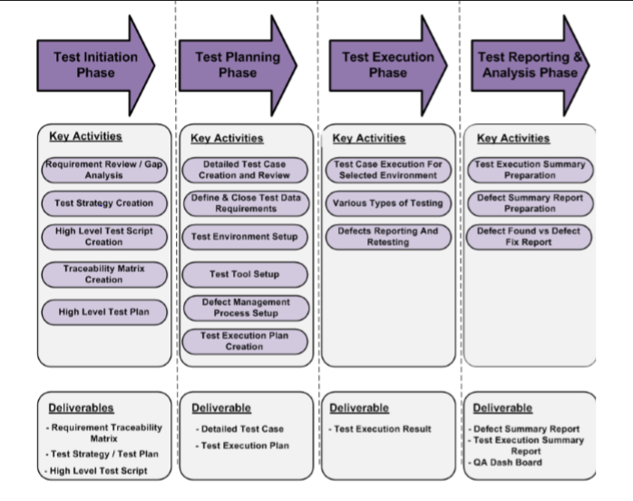

Black box testing: In black box testing, tester only know what the software is supposed to do –he can’t look in the box to see how it operate .If he types in a certain input, he gets a certain output. He doesn’t know how or why it happens. Just that it does.
So it is usually applied to static page. In static block box testing, this specification is a document, not an executing program, so it’s considered static. You can use this testing in our website, by this testing no matter what the format of the static page. It can be a written or graphical document or a combination of both.

White box testing: white box testing is an approach to testing where the test are derived from knowledge of the software structure and implementation. It is usually applied to relatively small program units such as sub-routines or the operations associated with an object or a small module of your system. Now to test individual system we have devised sample input for each module like for the User Subsystem we gave the input to perform different with valid and invalid data and update database entire accordingly.

Chapter 5:

Screenshots

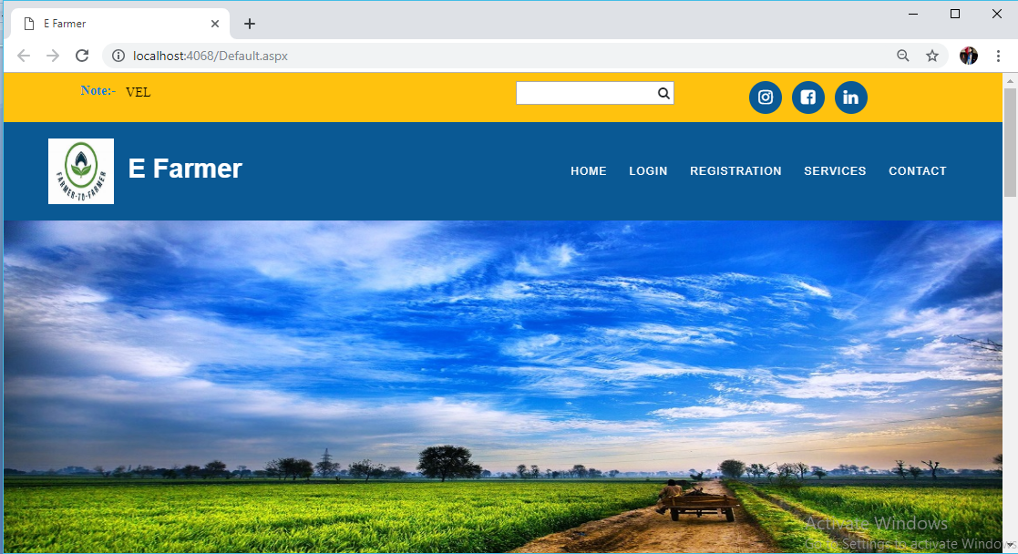

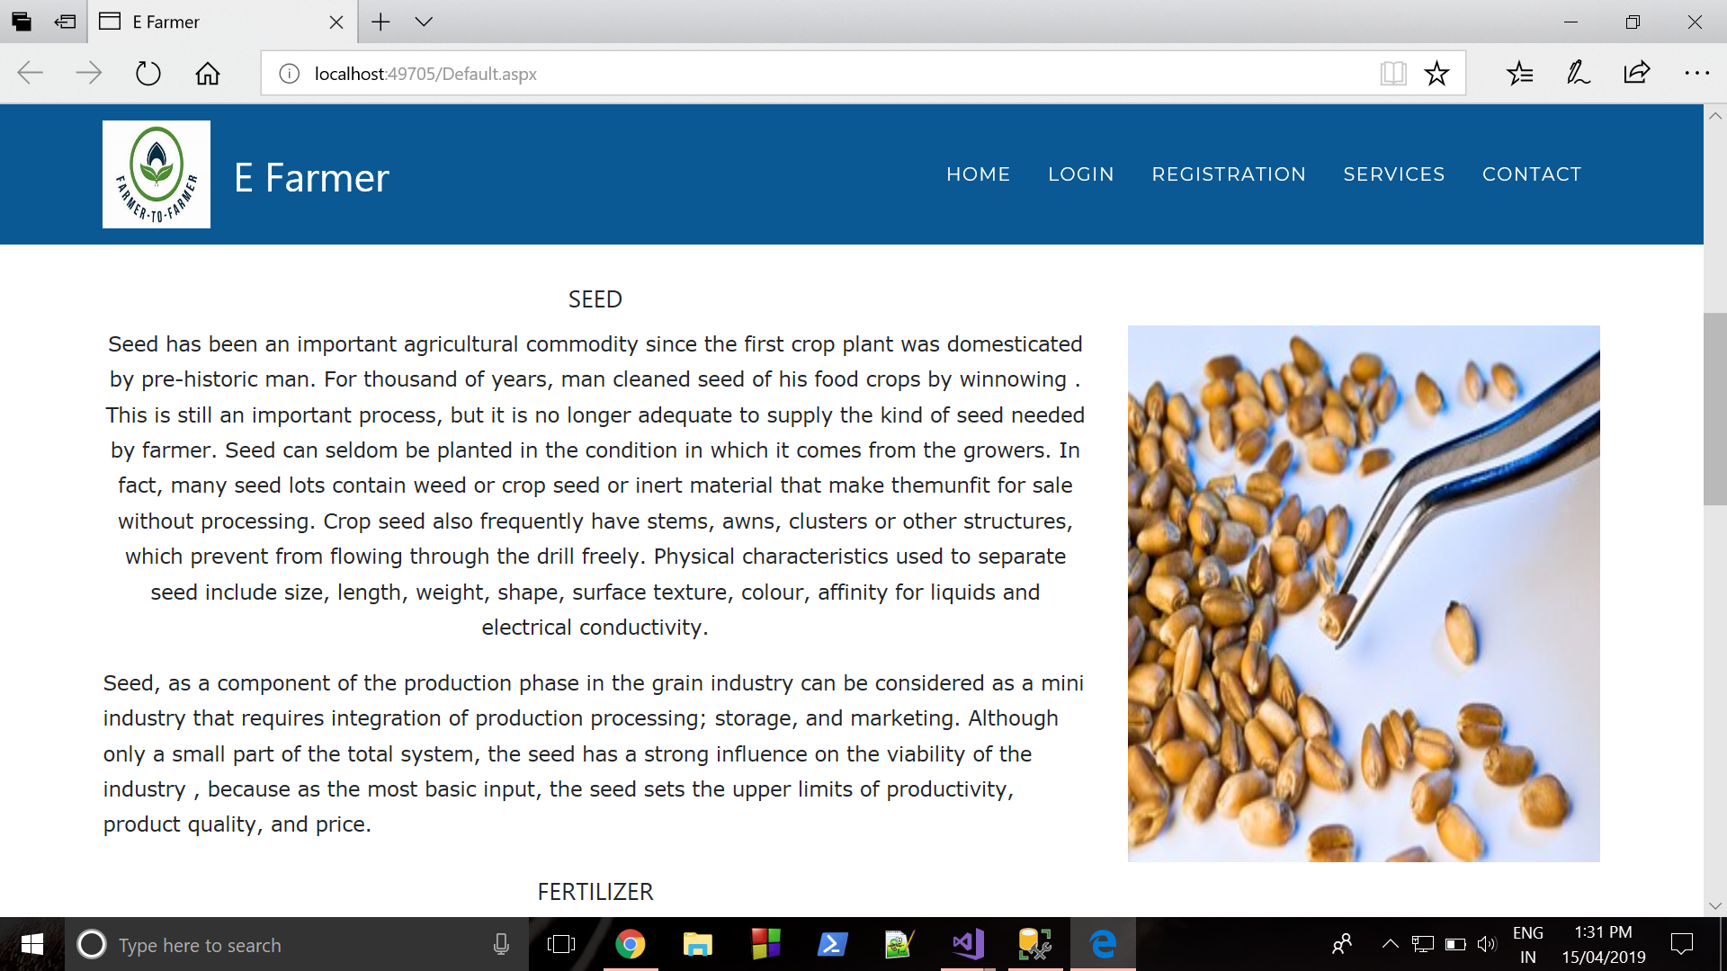

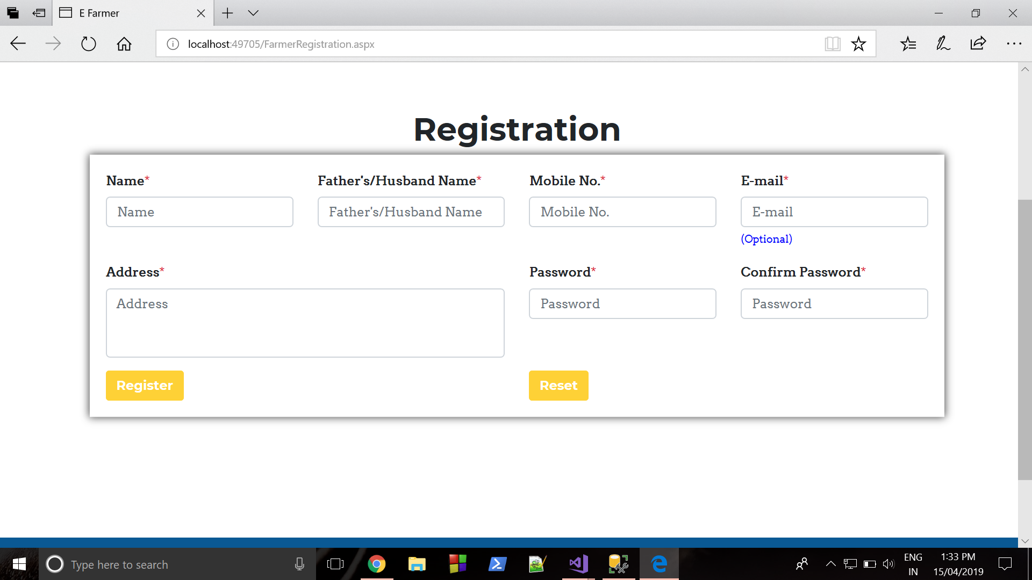

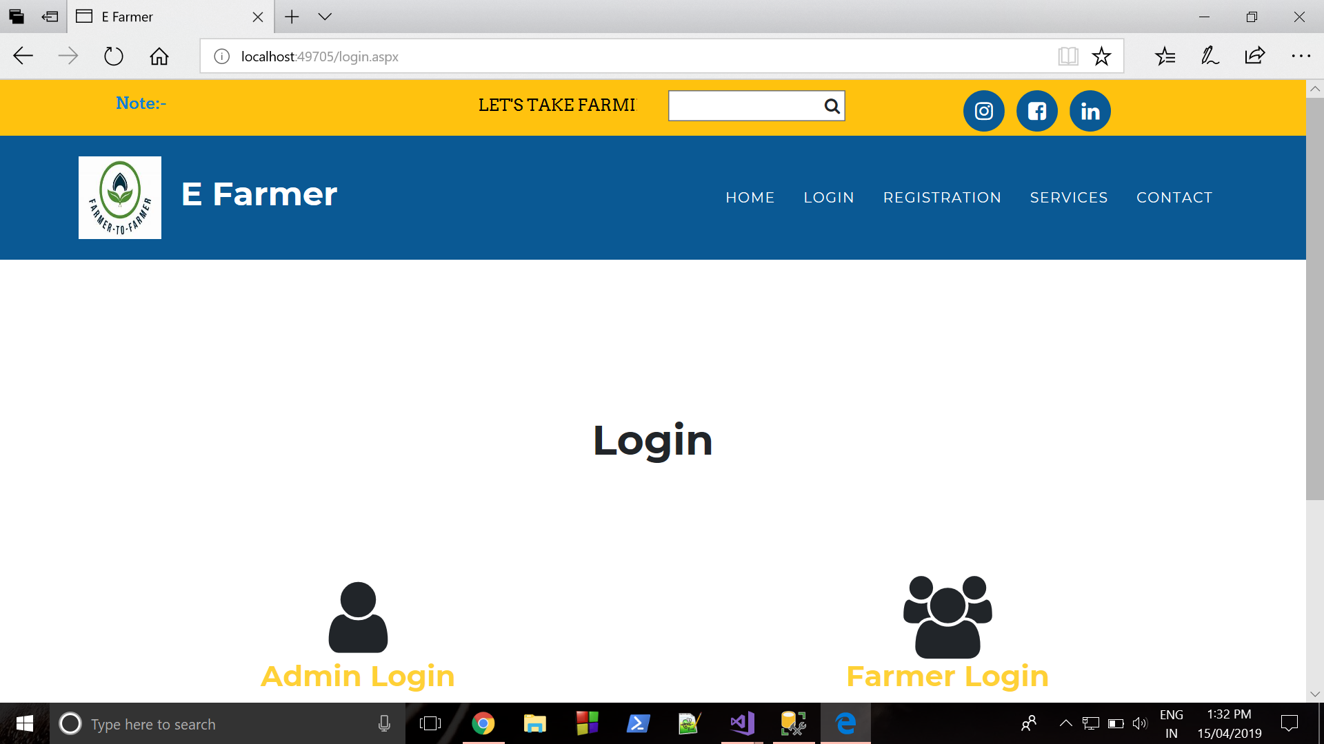

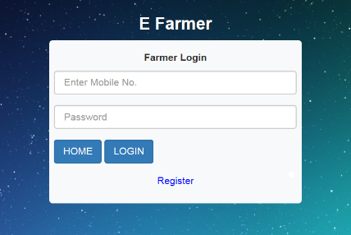

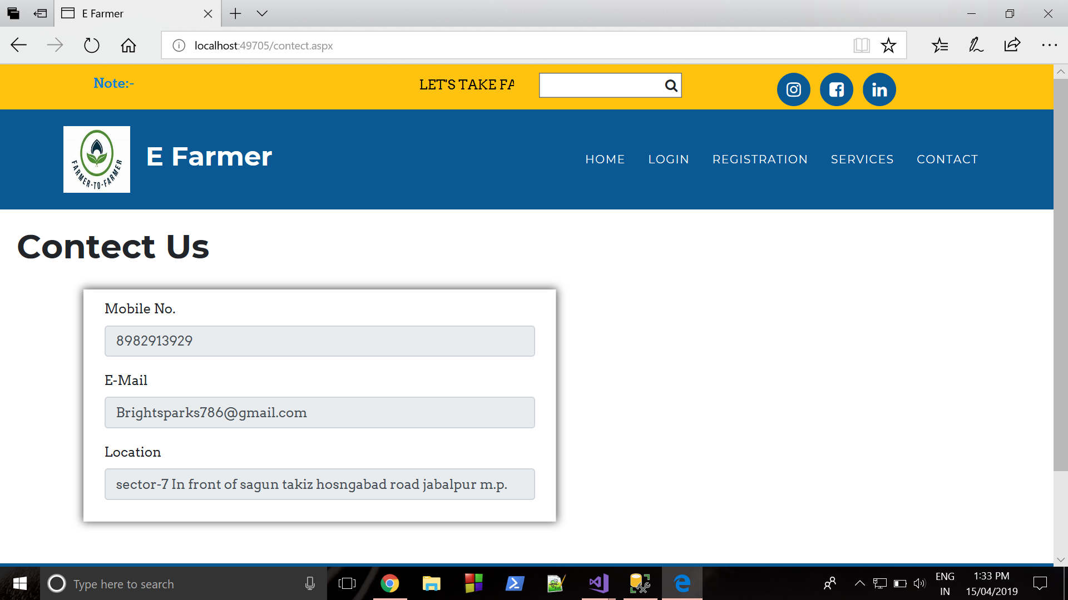

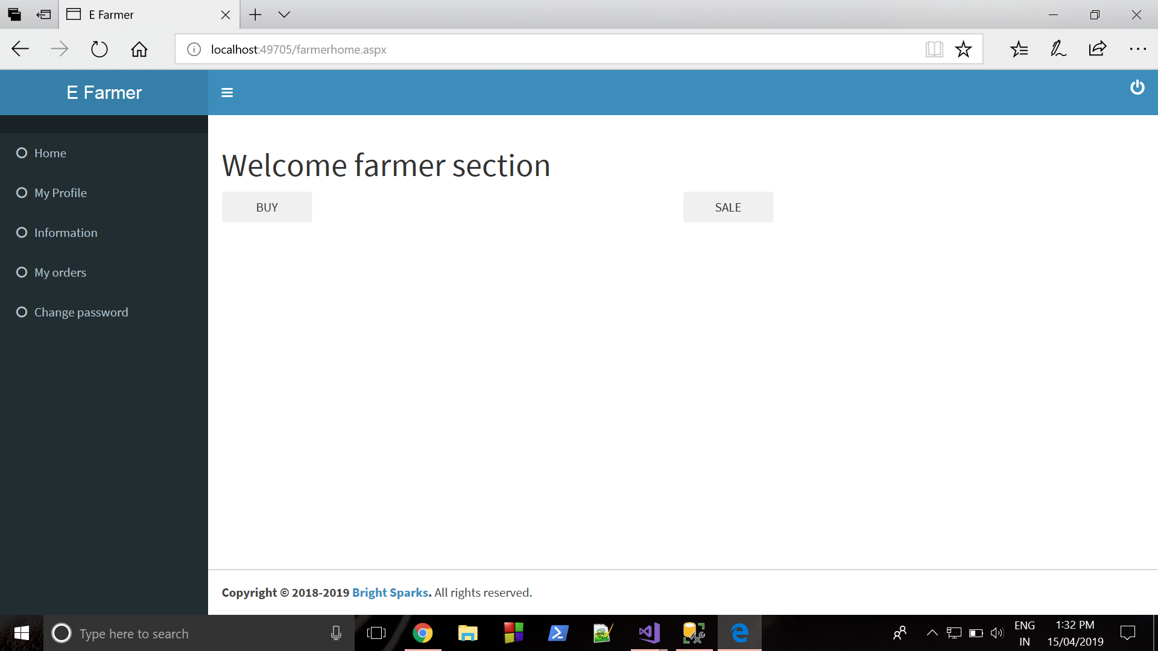

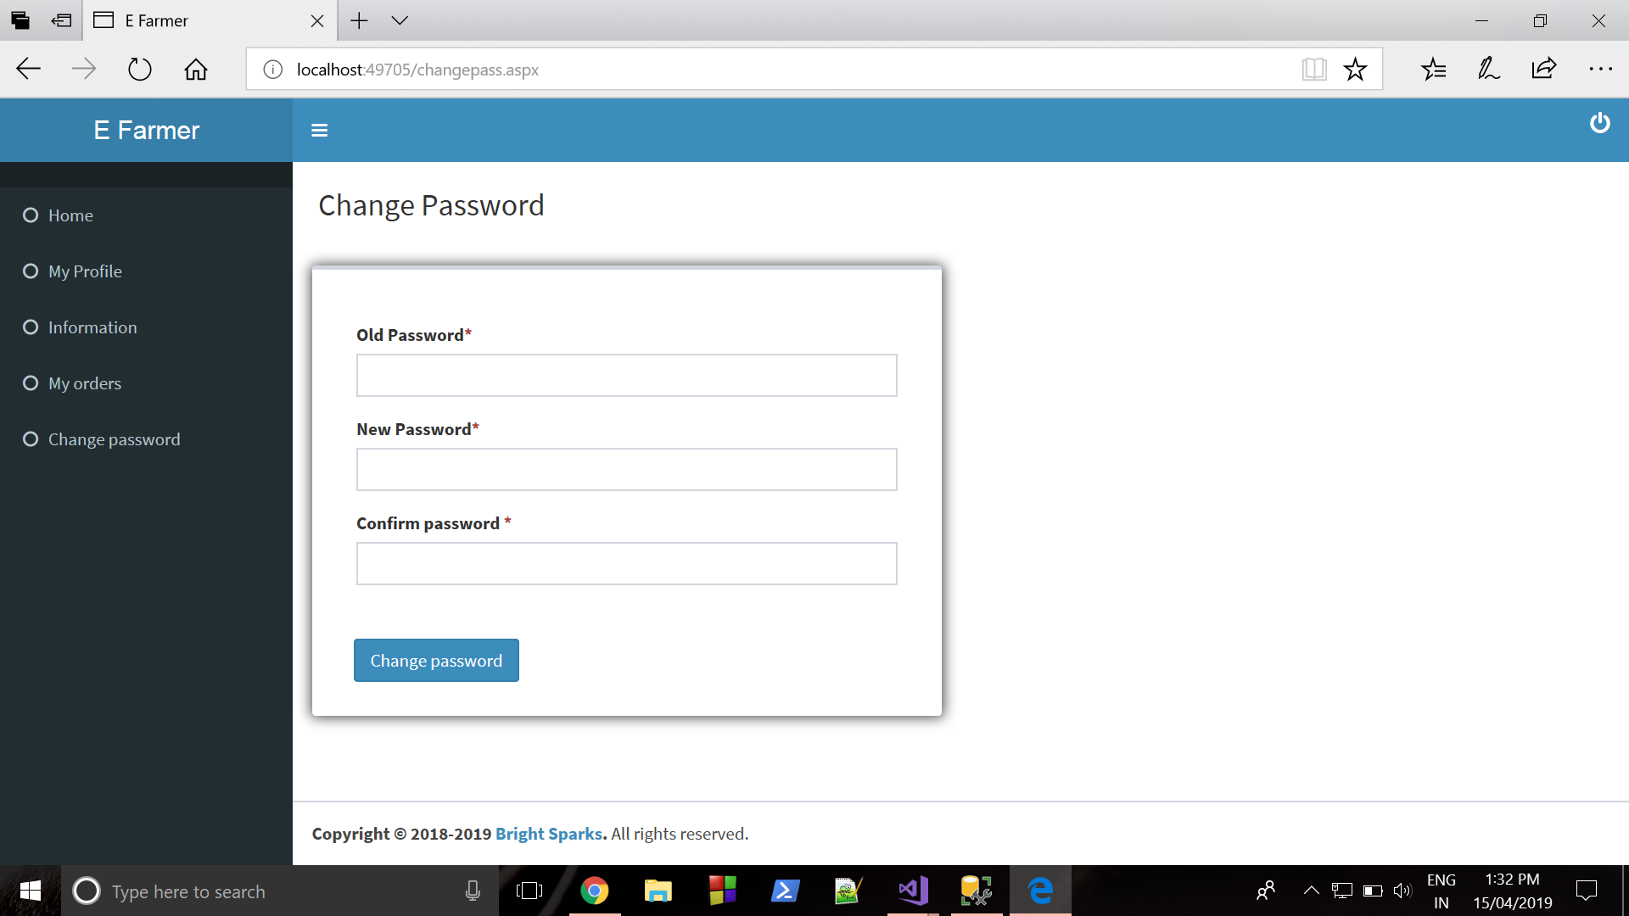

Chapter 6: Conclusion

The conclusions derived from the study are:
- Design Management is an area of engineering and project management that needs urgent attention, especially when global collaborative projects are to be executed.
- Emergent Changes and Internal Changes were the main causes of design changes on the Structural Steel component of the project. These were changes made to achieve project objectives, fix deficiencies, to correct errors, and to leverage misunderstandings between different design domains.
- The magnitude of design changes that occurred on the Structural Steel could not have been expected and planned for.A design management tool/method would have effectively managed the magnitude of design changes that occurred on project.
- A design management tool/method could have reduced the likelihood of disputes over design changes). Global Collaboration had a big impact on the magnitude of design changes that occurred on.
- In the final analysis, from the empirical and theoretical findings of the study, it was found that the system currently used by Murray & Roberts for managing design changes was ineffective. There is a need for a design management tool/method which would lead to less claims and disputes.

Recommendations
This section looks at the recommendations that can be made to stakeholders such as; Department of Energy and its departments; Eskom; Hitachi Power Europe; Murray & Roberts and all design contractors. This will enable the management of design to be enhanced and the running of projects to be a much smoother operation. The recommendations are guided by the objectives of the study.
1. Root causes of design changes
2. Design Management tools/systems
3. Appropriate Tool for Global Collaborative Projects.

Reference :

a) www.tutorialspoint.com
b) www.google.com
c) www.w3schools.com
d) www.youtube.com

